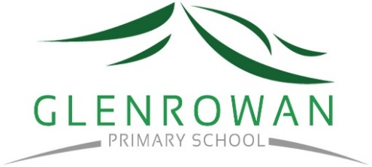
Glenrowan and Winton Primary School

Statement of Commitment to Child Safety

Glenrowan and Winton Primary Schools are a child safe organisation which welcomes all children, young people and their families.
We are committed to providing environments where our students are safe and feel safe, where their participation is valued, their views respected, and their voices are heard about decisions that affect their lives. Our child safe policies, strategies and practices are inclusive of the needs of all children and students.
We have no tolerance for child abuse and take proactive steps to identify and manage any risks of harm to students in our school environments.
We promote positive relationships between students and adults and between students and their peers. These relationships are based on trust and respect.
We take proactive steps to identify and manage any risk of harm to students in our school environment. When child safety concerns are raised or identified, we treat these seriously and respond promptly and thoroughly.
Particular attention is given to the child safety needs of Aboriginal students, those from culturally and linguistically diverse backgrounds, international students, students with disabilities, those unable to live at home, children and young people who identify as lesbian, gay, bisexual, trans and gender diverse, intersex and queer (LGBTIQ+) and other students experiencing risk or vulnerability. Inappropriate or harmful behaviour targeting students based on these or other characteristics, such as racism or homophobia, are not tolerated at our school, and any instances identified will be addressed with appropriate consequences.
Child safety is a shared responsibility. Every person involved in our school has an important role in promoting child safety and wellbeing and promptly raising any issues or concerns about a child’s safety.
We are committed to regularly reviewing our child safe practices, and seeking input from our students, families, staff, and volunteers to inform our ongoing strategies.

